Projeto Filtro IIR - Butterworth 1
Projeto Filtro FIR - Janela Ajustável 7
% %% Dados
% % LP - (fa = 4000 Hz, f1 = 1000 Hz; f2 = 1300 Hz, Ap = 2 dB, As = 30 dB, GdB = 5 dB)
% % IIR - Butterworth, FIR - Janela Ajustável

Projeto Filtro IIR - Butterworth
%clear all;
close all;
clc;
Ap = 2; % Ganho na banda de passagem em dB
As = 30; % Atenuação no stopband em dB
fa = 4000; % Hz
f1 = 1000; % Hz
f2 = 1300; % Hz
GdB = 5; % dB
fp = f1;
fs = f2;
thetap = fp/(fa/2);
thetas = fs/(fa/2);
lambdap = 2*tan((thetap*pi)/2);
lambdas = 2*tan((thetas*pi)/2);
Ws = lambdas/lambdap;
Wp = 1;
E = sqrt(10^(0.1*Ap)-1);
n = ceil((log((10^(0.1*As)-1)/E^2))/(2*log(Ws))); % ordem do filtro
k = 1:n;
pk = E^(-1/n)*exp((1j*(2*k+n-1)/(2*n)*pi));
a = real(poly(pk)); % denominador
b = 10^(GdB/20)*(a(end)); % numerador
syms p
Np(p) = poly2sym(b, p);
Dp(p) = poly2sym(a, p);
Hp(p) = Np(p) / Dp(p);
pretty(vpa(collect(Hp), 5)); % collect simplifica ao maximo a funcao
figure(1)
[h, w] = freqs(b,a, logspace(-1, 1, 10000));
semilogx(w, 20*log10(abs(h)));ylim([-60 10]);grid on;hold on;
% Máscara
plot([0.1,Ws,Ws,10],[0,0,-As,-As]+GdB, '--r')
plot([0.1,Wp,Wp,],[-Ap,-Ap,-80]+GdB, '--r')
title('H(p)');xlabel('rad/s');ylabel('dB');
hold off;
syms s
Hs(s) = collect(subs(Hp(p), s/lambdap));
[Ns, Ds] = numden(Hs(s));
pretty(vpa(Hs(s), 3))
bs = sym2poly(Ns);
as = sym2poly(Ds);
an = as(1);
bsn = bs/an;
asn = as/an;
Hsn(s) = poly2sym(bsn,s) / poly2sym(asn,s);
pretty(vpa(Hsn(s),5))
figure(2)
[hs,ws] = freqs(bsn,asn,linspace(0,8,10000));
plot(ws/pi, 20*log10(abs(hs)));ylim([-60 10]);
title('H(s)');xlabel('rad/s');ylabel('dB');
grid on; hold on;
% Fazer a máscara em cima do LAMBDA
plot([0,lambdas/pi,lambdas/pi,2],[0,0,-As,-As]+GdB, '--r')
plot([0,lambdap/pi,lambdap/pi],[-Ap,-Ap,-80]+GdB, '--r')
hold off;
syms z;
aux = 2*((z-1)/(z+1));
Hz(z) = collect(subs(Hs(s), aux));
pretty(vpa(Hz(z),3))
[Nz,Dz] = numden(Hz(z));
bz = sym2poly(Nz);
az = sym2poly(Dz);
an = az(1);
bzn = bz/an;
azn = az/an;
Hzn(z) = poly2sym(bzn,z) / poly2sym(azn,z);
pretty(vpa(Hzn(z),5))
figure(3)
subplot(211)
[hz, wz] = freqz(bzn, azn, linspace(0, pi, 10000));
plot(wz/pi*fa/2, 20*log10(abs(hz)));ylim([-40 10]);
title_txt = ['H(z) - BP - Filtro IIR - Butterworth - N = ' num2str(n)];
title(title_txt);xlabel('Hz');ylabel('dB');
grid on;hold on;
% Máscara
plot([0.01,fs,fs,2000],[0,0,-As,-As]+GdB, '--r')
plot([0.01,fp,fp,],[-Ap,-Ap,-80]+GdB, '--r')
subplot(212)
plot(wz/pi*fa/2, 20*log10(abs(hz)));ylim([0 8]);xlim([800 1100]);
title_txt = ['H(z) - BP - Filtro IIR - Butterworth - N = ' num2str(n)];
title(title_txt);xlabel('Hz');ylabel('dB');
grid on;hold on;
% Máscara
plot([0.01,fs,fs,2000],[0,0,-As,-As]+GdB, '--r')
plot([0.01,fp,fp,],[-Ap,-Ap,-80]+GdB, '--r')
hold off;
figure(4)
subplot(121)
zplane(bzn, azn);title('Diagrama de pólos e zeros');xlabel('Parte real');ylabel('Parte imaginária');axis([-2 2 -3 3]);
subplot(122)
grpdelay(bzn, azn);title('Atraso de grupo');
xlabel('Frequência normalizada [x\pi rad/amostra]');
ylabel('Atraso de grupo [amostra]');
%%%%%%%%%%%%%%%%%%%%%%%%%%%%%%%%%%%%%%%%%%%%%%%%%%%%%%%%%%%%%%%%%%
figure(5)
subplot(211)
x=10^(-0.174/20);
% valores retirados do Filter Designer
Den = [1 0.15625 1.0625 0.125 0.28125 0.03125 0.03125 0 0];
Num = [0.03125 0.15625 0.53125 1.0625 1.3125 1.0625 0.53125 0.15625 0.03125];
q=quantizer([6,5]);
xq=quantize(q,x)
binxq=num2bin(q,xq);
N = Num*xq;
D = Den;
plot(wz/pi*fa/2, 20*log10(abs(hz)));
grid on;hold on;
[hzq, wzq] = freqz(N, D, linspace(0, pi, 10000));
plot(wzq/pi*fa/2, 20*log10(abs(hzq)));ylim([-40 10]);
title_txt = ['H(z) - BP - Filtro IIR - Butterworth - N = ' num2str(n)];
title(title_txt);xlabel('Hz');ylabel('dB');
% Máscara
plot([0.01,fs,fs,2000],[0,0,-As,-As]+GdB, '--r')
plot([0.01,fp,fp,],[-Ap,-Ap,-80]+GdB, '--r')
subplot(212)
plot(wz/pi*fa/2, 20*log10(abs(hz)));ylim([0 8]);xlim([800 1010]);
title_txt = ['H(z) - BP - Filtro IIR - Butterworth - N = ' num2str(n)];
title(title_txt);xlabel('Hz');ylabel('dB');
grid on;hold on;
plot(wzq/pi*fa/2, 20*log10(abs(hzq)));
% Máscara
plot([0.01,fs,fs,2000],[0,0,-As,-As]+GdB, '--r')
plot([0.01,fp,fp,],[-Ap,-Ap,-80]+GdB, '--r')
hold off;
figure(6)
subplot(121)
zplane(bzn, azn);title('Diagrama de pólos e zeros');xlabel('Parte real');ylabel('Parte imaginária');axis([-2 2 -3 3]);
subplot(122)
zplane(N, D);title('Diagrama de pólos e zeros');xlabel('Parte real');ylabel('Parte imaginária');axis([-2 2 -3 3]);
hold off;
%%%%%%%%%%%%%%%%%%%%%%%%%%%%%%%%%%%%%%%%%%%%%%%%%%%%%%%%%%%%%%%%%
16 15 8 16 7 16 6
(1.0472 10 )/(4.5036 10 p + 2.3872 10 p + 6.3266 10 p
17 5 17 4 17 3 16 2
+ 1.0879 10 p + 1.3229 10 p + 1.1634 10 p + 7.2344 10 p
16 15
+ 2.919 10 p + 5.8887 10 )
17 14 8 15 7 16 6 17 5
(3.35 10 )/(5.63 10 s + 5.97 10 s + 3.16 10 s + 1.09 10 s
17 4 17 3 17 2 17 17
+ 2.65 10 s + 4.65 10 s + 5.79 10 s + 4.67 10 s + 1.88 10 )
8 7 6 5 4 3
595.25/(s + 10.601 s + 56.192 s + 193.26 s + 469.99 s + 826.63 s
2
+ 1028.1 s + 829.62 s + 334.74)
16 8 16 7 17 6 17 5 17 4
(1.05 10 z + 8.38 10 z + 2.93 10 z + 5.86 10 z + 7.33 10 z
17 3 17 2 16 16 17 8
+ 5.86 10 z + 2.93 10 z + 8.38 10 z + 1.05 10 )/(5.56 10 z
16 7 17 6 16 5 17 4
+ 9.44 10 z + 5.97 10 z + 7.04 10 z + 1.65 10 z
16 3 16 2 14 13
+ 1.21 10 z + 1.17 10 z + 3.97 10 z + 9.88 10 )
8 7 6 5 4 3
(0.018818 z + 0.15054 z + 0.5269 z + 1.0538 z + 1.3172 z + 1.0538 z
2 8 7 6
+ 0.5269 z + 0.15054 z + 0.018818)/(z + 0.16961 z + 1.0725 z
5 4 3 2
+ 0.12659 z + 0.29667 z + 0.021683 z + 0.020985 z + 0.00071362 z
+ 0.00017747)
xq =
0.9688
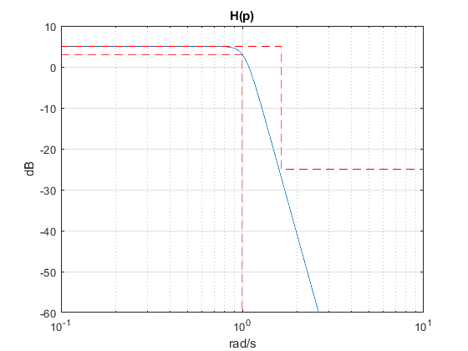
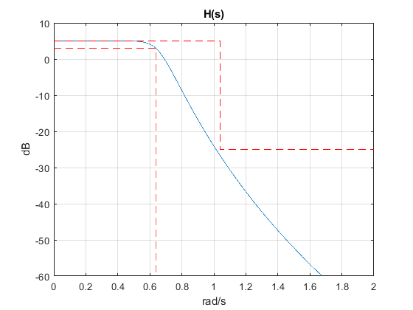
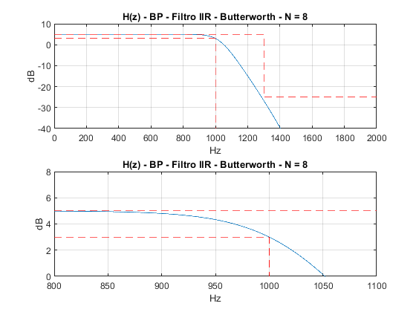
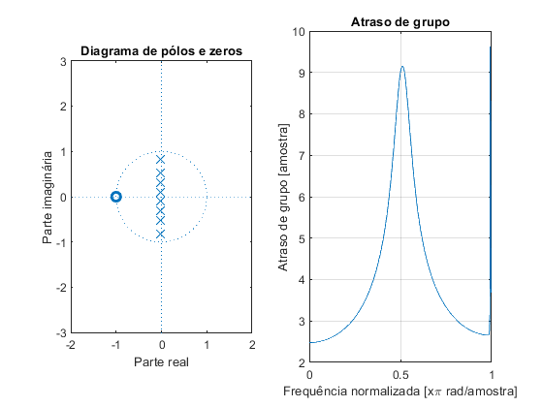
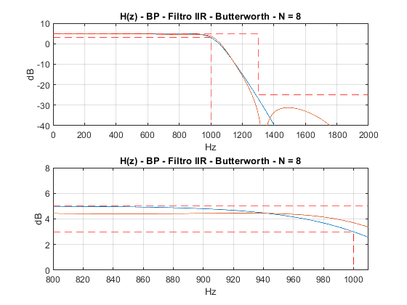
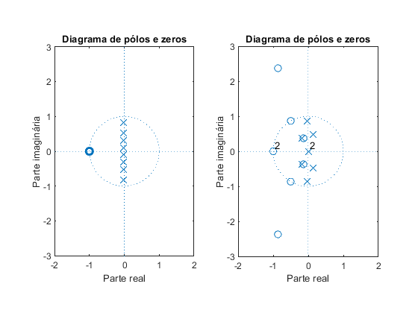

Projeto Filtro FIR - Janela Ajustável
%close all;
clear all;
clc;
Ap = 2; % Ganho na banda de passagem em dB
As = 30; % Atenuação no stopband em dB
fa = 4000; % Hz
f1 = 1000; % Hz
f2 = 1300; % Hz
GdB = 5; % dB
fp = f1; fs = f2;
ganho = GdB;
wp = fp/(fa)*(2*pi);
ws = fs/(fa)*(2*pi);
dw = (ws - wp);
wc = sqrt(wp*ws); % frequência de corte
betha = 0.5842*(As-21)^0.4+0.07886*(As-21);
n = ceil((As - 8)/(2.285*dw) +1);
if mod(n,2) == 1
%impar
n = n+1;
end
% Ajuste do ganho
GdB = GdB - 0.0379;
% % Primeiro ajuste de M
wp1 = 0.5318*pi; ws1 = 0.6373*pi;
Dw1 = ws1-wp1;
n1 = ceil(n*Dw1/dw);
n = n1;
% % Segundo ajuste de M
wp2 = 0.5178*pi; ws2 = 0.6641*pi;
Dw2 = ws2-wp2;
n2 = ceil(n*Dw2/dw);
n = n2;
wc = wc - 0.015*pi;
Jkaiser = kaiser(n+1,betha);
k = 1:(n/2);
b1 = sin(k*wc)./(k*pi);
b0 = wc/pi; % L'Hospital do b0 acima
b = [flip(b1) b0 b1];
b = b.'; % matriz b transposta
b = b.*Jkaiser*10^(GdB/20)*10^(-0.189/20);
figure(7)
subplot(211)
[h, w] = freqz(b, 1, linspace(0,pi,10000));
plot(w/pi*fa/2, 20*log10(abs(h))); grid on;
ylim([-60 10])
hold on;title_txt = ['BP - Filtro FIR - Janela ajustável Kaiser - N = ' num2str(n)];
title(title_txt);xlabel('Hz');ylabel('dB');
fmax = fa/2;
% Máscara
plot([0,fs,fs,fmax],[0,0,-As,-As]+ganho, '--red')
plot([0,fp,fp],[-Ap,-Ap,-140]+ganho, '--red');hold off;
subplot(212)
plot(w/pi*fa/2, 20*log10(abs(h))); grid on;hold on;
title_txt = ['BP - Filtro FIR - Janela ajustável Kaiser - N = ' num2str(n)];
title(title_txt);xlabel('Hz');ylabel('dB');xlim([800 1020]); ylim([-5 10]);
% Máscara
plot([0,fs,fs,fmax],[0,0,-As,-As]+ganho, '--red')
plot([0,fp,fp],[-Ap,-Ap,-140]+ganho, '--red');
hold off;
figure(8)
subplot(121)
zplane(b,1);title('Diagrama de pólos e zeros');xlabel('Parte real');ylabel('Parte imaginária');axis([-2 2 -3 3]);
subplot(122)
grpdelay(b,1);title('Atraso de grupo');
xlabel('Frequência normalizada [x\pi rad/amostra]');
ylabel('Atraso de grupo [amostra]');
%%%%%%%%%%%%%%%%%%%%%%%%%%%%%%%%%%%%%%%%%%%%%%%%%%%%%%%%%%%%%%%%%%
figure(9)
subplot(211)
x=10^(-0.1/20);
% valores retirados do Filter Designer
Num = [0.03125 -0.015625 -0.046875 0.0546875 0.0703125 -0.140625 -0.0859375 0.5390625 0.960937500000000 0.5390625 -0.0859375 -0.140625 0.0703125 0.0546875 -0.046875 -0.015625 0.03125];
q=quantizer([8,7]);
xq=quantize(q,x)
binxq=num2bin(q,xq);
N = Num*xq;
plot(w/pi*fa/2, 20*log10(abs(h))); grid on;
grid on;hold on;
[hq, wq] = freqz(N, 1, linspace(0, pi, 10000));
plot(wq/pi*fa/2, 20*log10(abs(hq)));ylim([-40 10]);
title_txt = ['BP - Filtro FIR - Janela ajustável Kaiser - N = ' num2str(n)];
title(title_txt);xlabel('Hz');ylabel('dB');
% Máscara
plot([0.01,fs,fs,2000],[0,0,-As,-As]+GdB, '--r')
plot([0.01,fp,fp,],[-Ap,-Ap,-80]+GdB, '--r')
subplot(212)
plot(w/pi*fa/2, 20*log10(abs(h)));ylim([0 8]);xlim([800 1010]);
title_txt = ['BP - Filtro FIR - Janela ajustável Kaiser - N = ' num2str(n)];
title(title_txt);xlabel('Hz');ylabel('dB');
grid on;hold on;
plot(wq/pi*fa/2, 20*log10(abs(hq)));
% Máscara
plot([0.01,fs,fs,2000],[0,0,-As,-As]+GdB, '--r')
plot([0.01,fp,fp,],[-Ap,-Ap,-80]+GdB, '--r')
hold off;
figure(10)
subplot(121)
zplane(b, 1);title('Diagrama de pólos e zeros');xlabel('Parte real');ylabel('Parte imaginária');axis([-2 2 -3 3]);
subplot(122)
zplane(N, 1);title('Diagrama de pólos e zeros');xlabel('Parte real');ylabel('Parte imaginária');axis([-2 2 -3 3]);
hold off;
%%%%%%%%%%%%%%%%%%%%%%%%%%%%%%%%%%%%%%%%%%%%%%%%%%%%%%%%%%%%%%%%%
xq =
0.9844
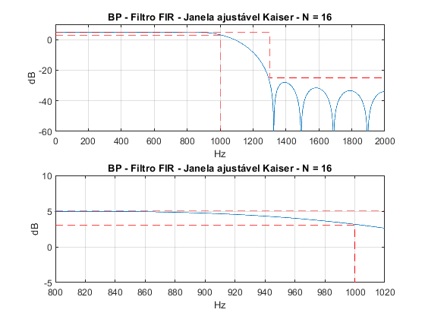
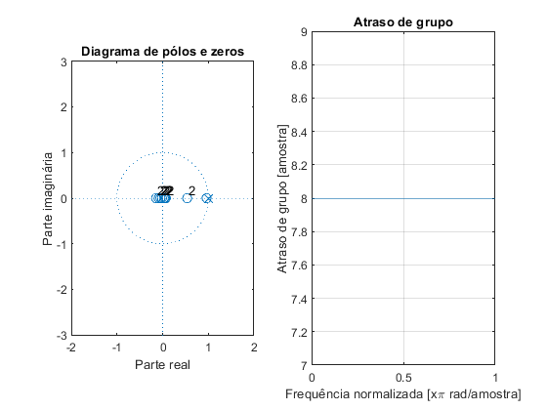
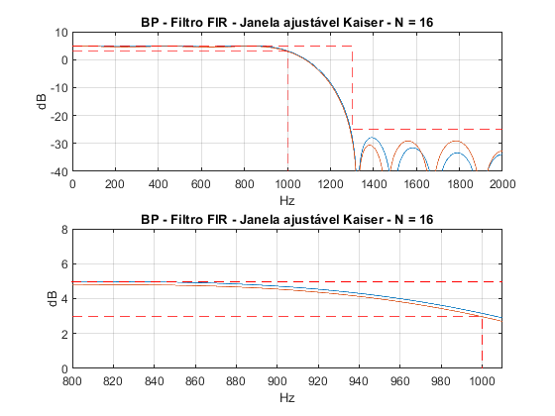
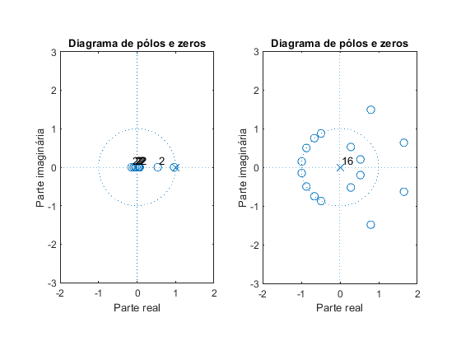
Published with MATLAB® R2018a

